**Super Store Sales Dashboard**

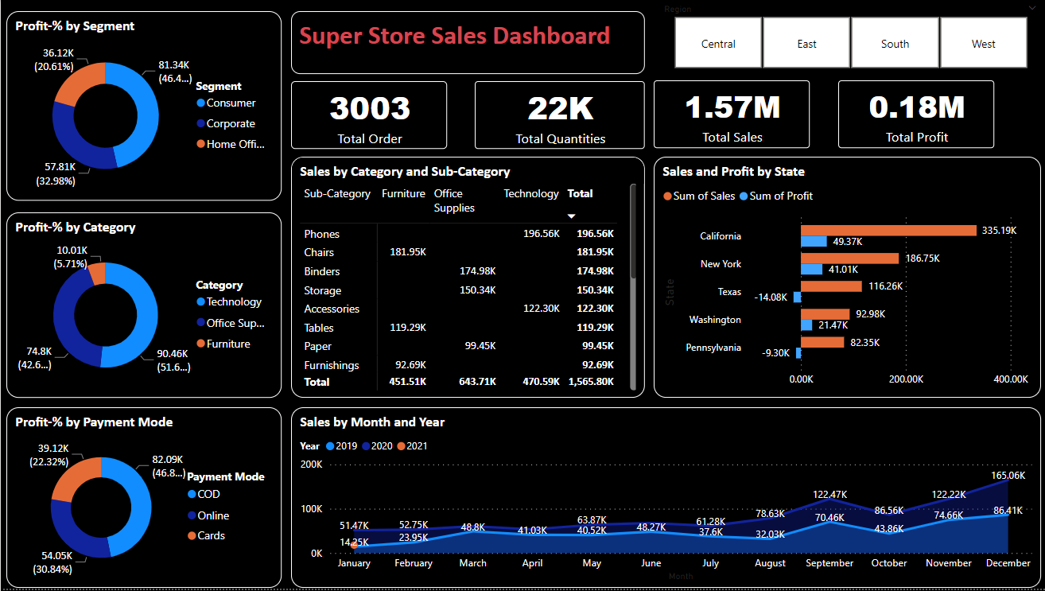

**Identifying How negative profits are generated, tracking back the real cause of negative profits using decomposition tree chart.**

**Analysing monthly sales with respective to ‘Category’ and ranking them according using ribbon chart.**

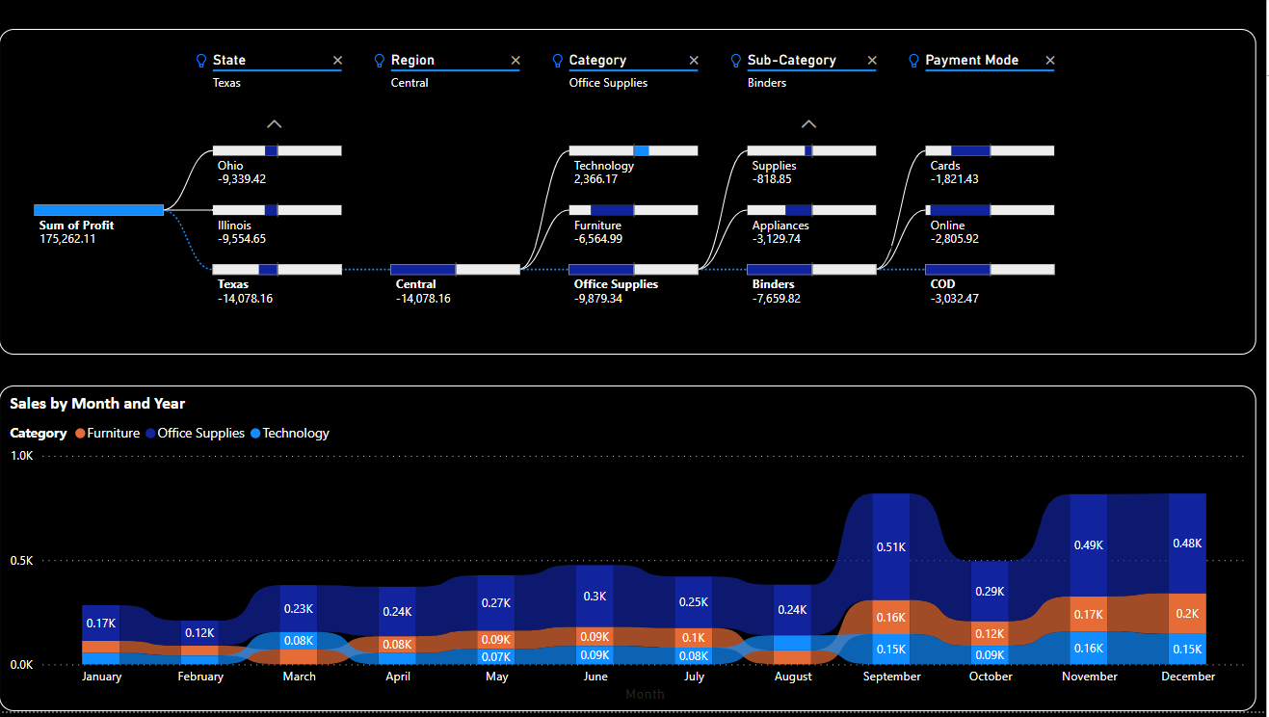

**Identifying How low sales are generated, tracking back the real cause of low sales using decomposition tree chart.**

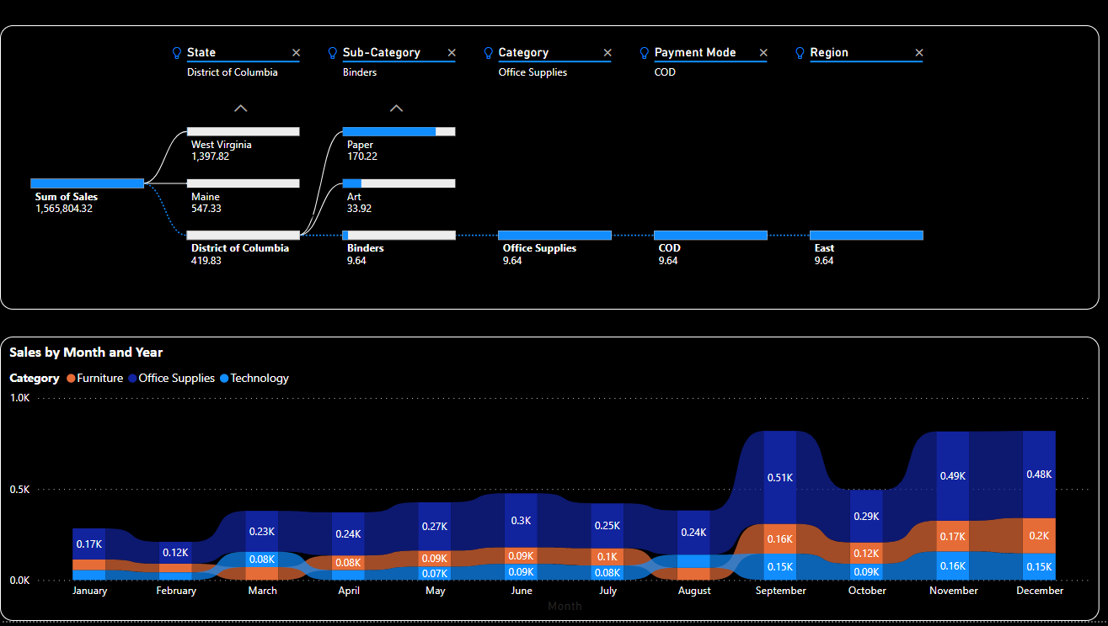

**Sales Forecast for the next 4 months**

